**Understanding Multi-Host Networking**

* Multi-host networking is created as part of docker orchestration called as SWARM
* <https://directdevops.blog/2019/10/07/docker-networking-series-ii-overlay-networks/> for multi host networking and <https://directdevops.blog/2019/10/07/docker-swarm-mode/> for swarm
* According to what we have learnt so far. Communication between containers in same host is possible using bridge or macvlan etc. but communication between two containers running on two different hosts is not possible  
  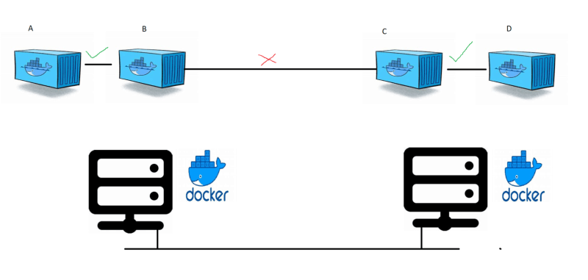
* Docker has a netwok driver called as overlay network
* Using vxlan, overlay networks use underlay to create a virtual network which is logical and appears as if the containers across hosts are connected to the same network  
  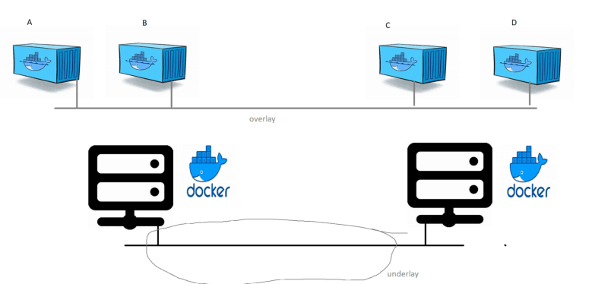
* To create multi host network, we need to create docker swarm cluster.
* Swarm cluster provides native docker container orchestration.
* Some of the activities the cluster performs
  + Maintains the desired state.
  + Performs scaling
  + chooses the master node (manager)
  + ability to add docker hosts to the cluster